02/02/24
Teacher: L. Korniienko
Topic: English writers and poets
What kind of literature do you prefer to read?
What English (British)writers do you know?
What is your favourite English writer?
What is your attitude towards poetry?
What English (British)
poets do you know?
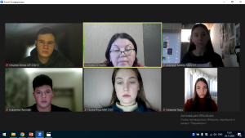

09/02/24
Speaker: Marcus Ferrar, Oxford, UK.
Topic: History
Questions for discussion:
Why is it important?
Who makes the history?
How does it help to understand own society, identity and other cultures?
History allows us to learn from the past
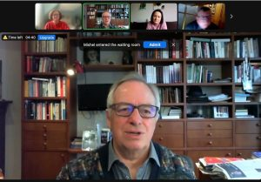

16/02/24
Speaker: Tetiana Marchenko
Topic: Motivation. Goal
Questions for discussion:
How motivated are you in general?
- What motivates you to do things?
- What is the best motivator to succeed?
- What do you do when you feel unmotivated?
- What is a good way to motivate others?
- We all have goals and talking about them actually gets people more encouraged to do something about them.
- Sharing goals is also a good way to help get them achieved.
- What are your current goals in life?
- How do you plan to reach your goals?
- How often do you set goals for yourself?
- What goals have you set and achieved in the past?
- How do you feel when you reach your goals?
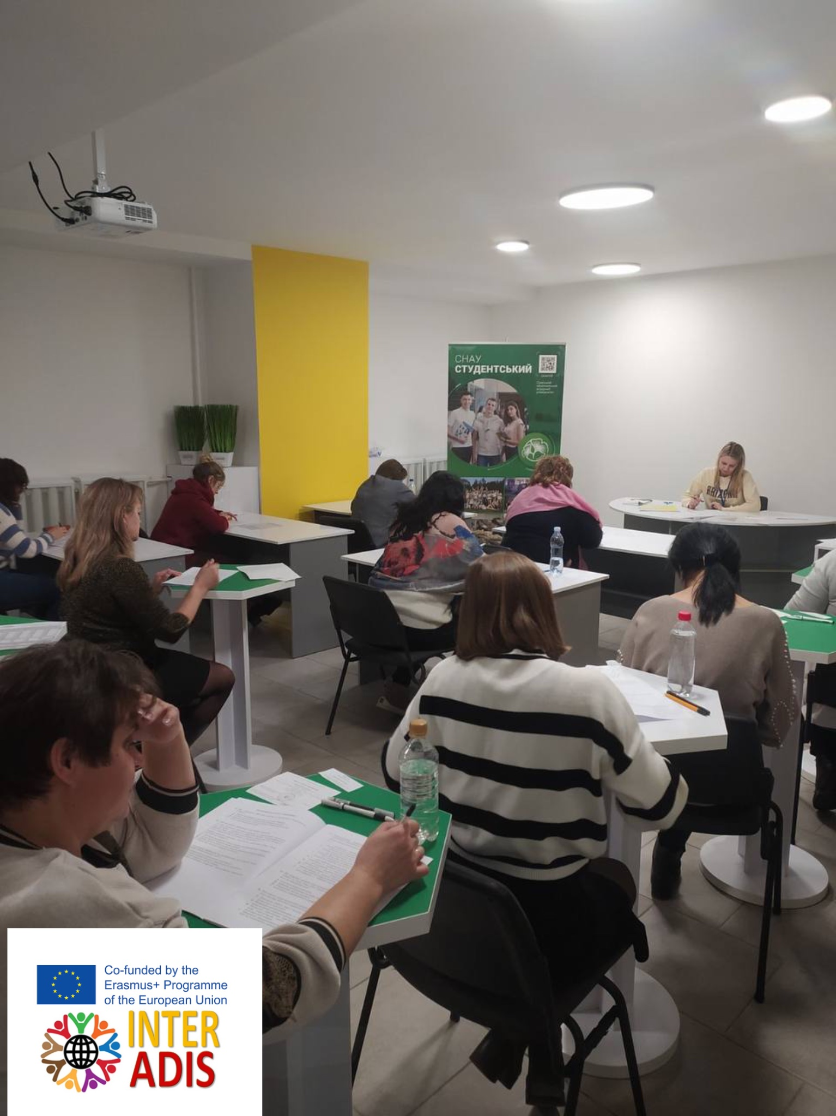

23/02/24
Speaker: Vasyl Bilokopytov
Topic: Time. Time Management
Questions for discussion:
How much free time do you usually have?
How important is time to you?
If you had more free time, what would you do?
“Time is money.” Do you agree or disagree? Why?
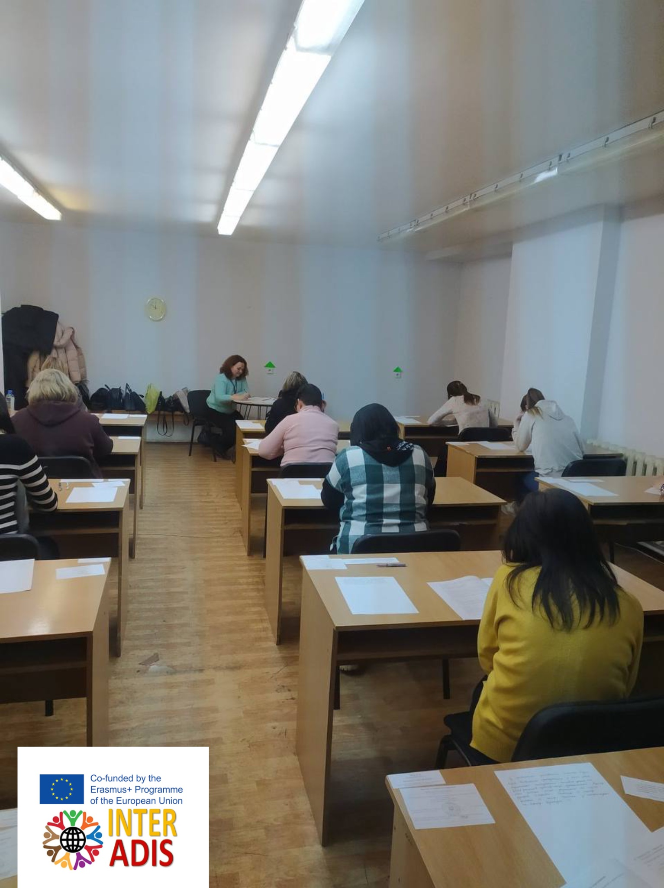
How do you feel about time that is wasted?

01/03/24
Speaker: Nataliia Marchenko
Topic: Professions.
Questions to think over:
Who influenced your choice of the future profession?
What are the most in demand jobs now?
Which jobs will be in demand in the nearest future?
How do people apply for new vacancies?
Is it easy for university graduates to find jobs that suit their qualifications?
Do you agree that there is no such thing as a job for life these days?

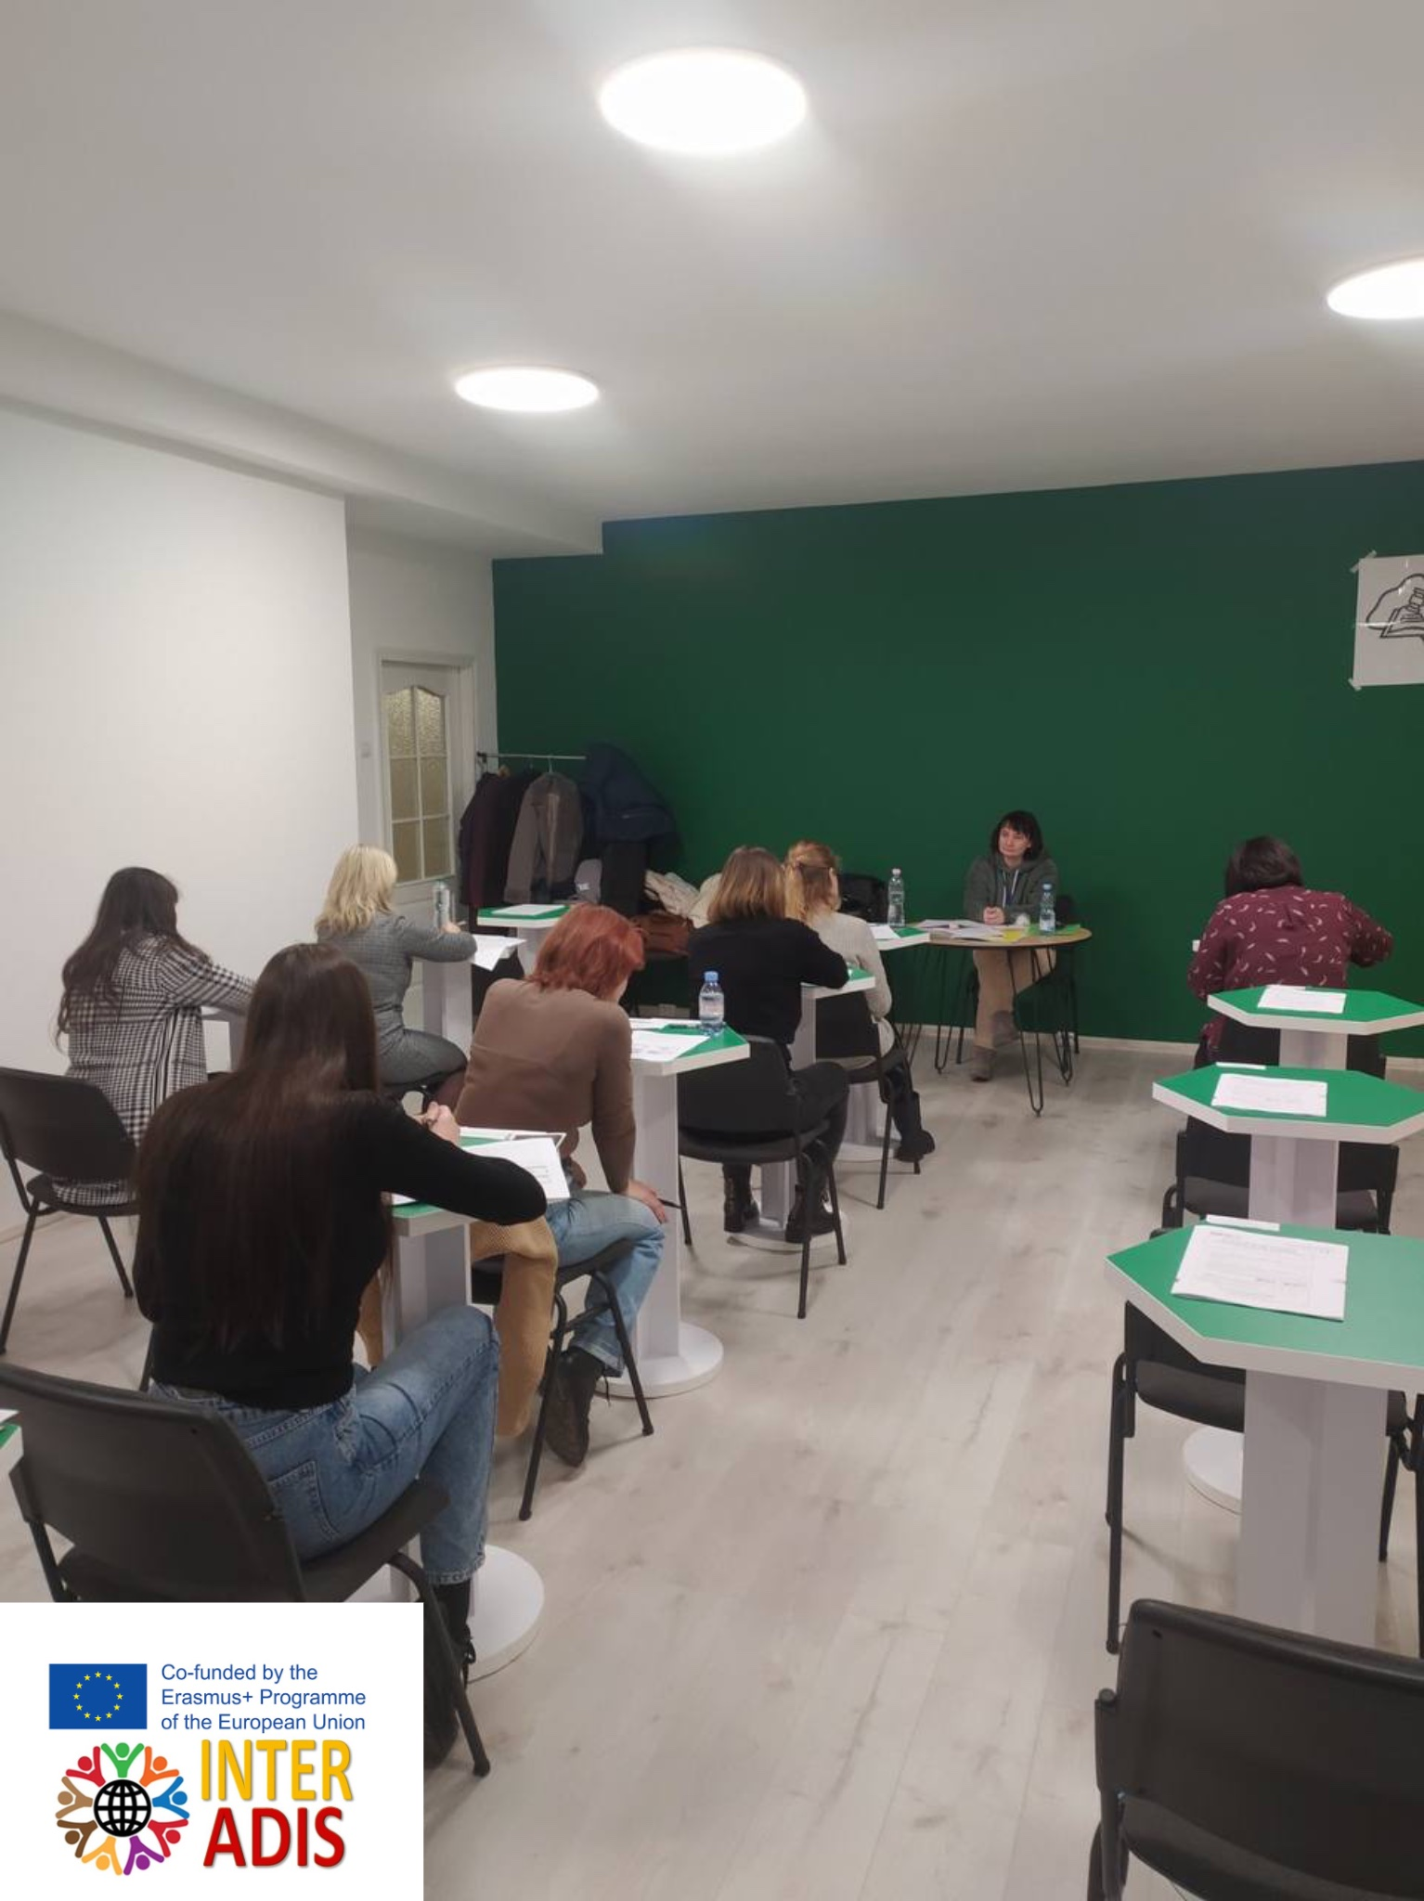
08/03/24
Speakers: Hanna Tsyhanok, Patricia Crentsil
Topic: Food
Questions to think over:
What is healthy and unhealthy food for you?
How many meals a day do people have?
What do people usually eat for breakfast, lunch, dinner, supper?
What do they drink?
What is the biggest meal of the day for you?
What do you like to eat in different seasons? What do you think it depends on?
Can you tell us about your favorite recipe from your Family Cookery book.

15/03/24
Speakers: Oksana Lytvynko, Bradley Cimo (USA), Maria Spellacy (UK)
Topic: Keeping fit
Questions to think over:
- What do you usually do to be healthy and strong?
- Is it good for your health to exercise every day?
- What kind of physical activity do you prefer?
- Is it harmful to eat junk food? What is your favorite junk food?
- What healthy habits do you know?
- Do you enjoy healthy food? What is healthy food for you?
- Do you have a snack every time you are hungry or do you wait for the lunch or dinner? What is better for health?

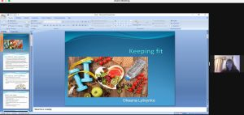
22/03/24
Speaker: Liudmyla Baidak
Topic: Holidays. Festivals. Celebrations
Questions to think over:

How important are festivals in your country?
What are the most important festivals and celebrations in Ukraine?
What local festivals in your country would be most interesting for a foreign guest?
How do you feel about attending festivals and celebrations that attract huge crowds?
Do you think the way we celebrate different festivals is changing?
Do festivals bring people from different cultures together?

29/03/24
Speaker: Tetiana Ridel
Topic: Travel
- Comment upon the following quotation – “The world is a book and those who do not travel read only one page.” Augustine of Hippo (354 – 430), theologian and philosopher
- Comprehension questions
- What do you think of when you hear the word “travel”?
- Do you enjoy travelling? Why or why not? What are the benefits of travelling?
- When was the last time you went on holiday/vacation? Can you describe it?
- Where would you like to go to on your next holiday/vacation?
- What are the best places you have been to?
- Where is the worst place you have been on holiday/vacation?
- Where would you recommend a foreign tourist visit in our country?
- Would you prefer to have a trip in our own country or in a foreign country? Why?
- Are you a traveler or a tourist? What’s the difference?
- What are some of the different types of holidays or vacations that people like to go on? (e.g., beach holidays, skiing holidays, etc.)
- Where are the best places to go for a romantic getaway?
- When you travel somewhere, do you like to plan everything or ‘go with the flow’?
- Have you ever travelled solo? If not, would you like to travel solo?
- Why do some people travel solo? What are the advantages and disadvantages of solo travel?
- Would you like to travel for a year or two? If so, which destinations would you choose and why?
- Are there any countries you would definitely not want to visit? Why?
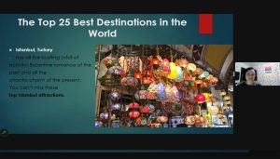
05/04/24
Speaker: Olha Tamarkina
Topic: Music in our life

- How often do you listen to music?
- What emotions does music evoke in you?
- Do you listen to music as you study or work?
- What music do you dislike?
- What is the best time and place to listen to music?
- What famous Ukrainian composers do you know?
- What famous Ukrainian singers do you like /dislike?
- What British singers do you know?
- Do you like /dislike them?
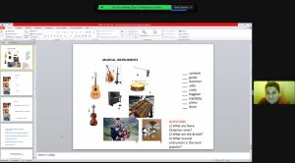
12/04/24
Speakers: Yuliia Lushchyk.

Topic: Media Manipulation.

1.What are positive and negative effects of media?
- Do you trust media sources? Why? Why not?
3.Can you distinguish disinformation, misinformation, and mal-information?
4.What is media manipulation?
5.Have you ever noticed any samples of psychological manipulation in advertisements? Which ones?
6.Why do people use image manipulation?
7.What is the purpose of headlines?
8.What are the ways to prevent media manipulation?
